 | Sinhgad Technical Education Society’s  RMD Sinhgad School of Engineering, Warje, Pune.  Department of Electronics & Telecommunication Engineering.

Name of Student | Aditya Ravindra Ghayal
Division | A
Roll Number | 23
Experiment Title | OFDM – BER Vs Eb/N0
Marks

 | Sinhgad Technical Education Society’s  RMD Sinhgad School of Engineering, Warje, Pune.  Department of E&TC Engineering | Expt.No.  8
Title | OFDM – BER Vs Eb/N0

Aim
Program to implement OFDM and evaluate frame error rate against SNR.

Apparatus
PC, Octave

Theory
To simulate an OFDM system, following design parameters are essential. Let us consider the OFDM
system parameters as defined in IEEE 802.11[IEEE80211] specifications. The sample parameters
derived in the previous section are used here as inputs for simulation.
Given parameters in the spec:
N=64;%FFT size or total number of subcarriers (used + unused) 64
Nsd = 48;%Number of data subcarriers 48
Nsp = 4 ;%Number of pilot subcarriers 4
ofdmBW = 20 * 10^6 ; % OFDM bandwidth
Derived Parameters:
deltaF = ofdmBW/N;% Bandwidth for each subcarrier - include all used and unused subcarriers
Tfft = 1/deltaF;% IFFT or FFT period = 3.2us
Tgi = Tfft/4;% Guard interval duration - duration of cyclic prefix - 1/4th portion of OFDM symbols
Tsignal = Tgi+Tfft;% Total duration of BPSK-OFDM symbol = Guard time + FFT period
Ncp = N*Tgi/Tfft;%Number of symbols allocated to cyclic prefix
Nst = Nsd + Nsp;% Number of total used subcarriers
nBitsPerSym=Nst;%For BPSK the number of Bits per Symbol is same as number of subcarriers
We will use the following model for simulating the OFDM system.
The channel in this case is modeled as a simple AWGN channel. Since the channel is considered to
be an AWGN channel, there is no need for the frequency domain equalizer in the OFDM receiver
(Frequency domain equalizer will be helpful only if the channel introduces multipath fading). Since
our channel is an AWGN channel, the frequency domain equalizer block in the above diagram can be
removed.
Calculating E S /N 0 or E b /N 0 for OFDM system:
In order to do a Monte Carlo simulation of an OFDM system, required amount of channel noise has to
be generated that is representative of the required E b /N 0 . In Matlab it is easier to generate a Gaussian
noise with zero mean and unit variance. The generated zero-mean-unit-variance noise has to be
scaled accordingly to represent the required E b /N 0 or E S /N 0 . If we have E S /N 0 , the required noise can
be generated from zero-mean-unit-variance-noise by,
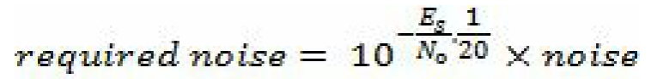
Since the OFDM system transmits and receives the data in symbols, it is appropriate/easier togenerate the required noise based on E S /N 0 instead of E b /N 0 (as given above). But we are interested in
plotting BER against E b /N 0 . Ok!!! Then… how do we convert given E b /N 0 to E S /N 0 for an OFDM
system?
Normally for a simple BPSK system, bit energy and symbol energy are the same. So E b /N 0 and E S /N 0
are the same for a BPSK system. But for an OFDM BPSK system, they are not the same. This is
because; each OFDM symbol contains additional overhead in both time domain and frequency
domain. In the time domain, the cyclic prefix is an additional overhead added to each OFDM symbol
that is being transmitted. In the frequency domain, not all the subcarriers are utilized for transmitting
the actual data bits, rather a few subcarriers are unused and are reserved as guard bands.
Effect of Cyclic Prefix on E S /N 0 :
The following diagram illustrates the concept of cyclic prefix. Each OFDM symbol contains both
useful data and overhead (in the form of cyclic prefix). The bit energy represents the energy contained
in the useful bits. In this case, the bit energy is spread over N bits (where N is the FFT size). On top
of the useful data, additional Ncp bits are added as cyclic prefix, which forms the overhead. So if the
entire OFDM symbol is considered, the symbol energy is spread across N+Ncp bits.
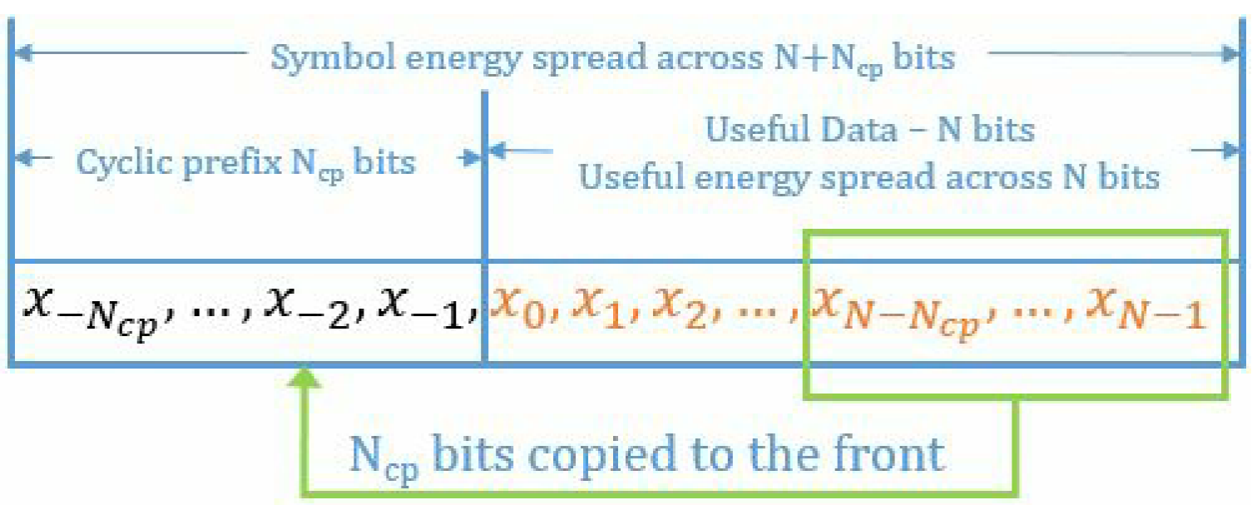
This relationship is given as
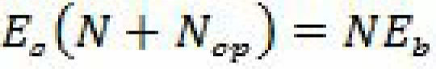
which translates to,
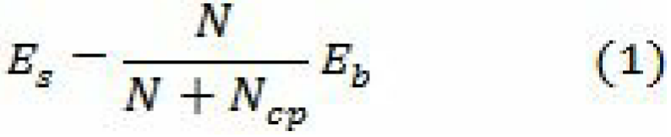
Effect of unused subcarriers on Es/N0:
As mentioned earlier, not all the subcarriers are used for transmission. Out of the total N subcarriers,
only Nst carriers are used for the OFDM symbols transmission (this includes both data and pilot
subcarriers). Again, in the frequency domain, the useful bit energy is spread across Nst subcarriers,
whereas the symbol energy is spread across N subcarriers. This gives us another relationship
between E S and E b as given below
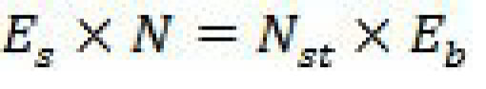
which translates to,
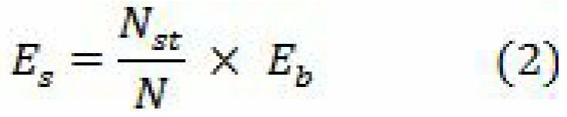
From (1) and (2), the overall effect of both cyclic prefix and unused subcarriers on Es/N0 is given by
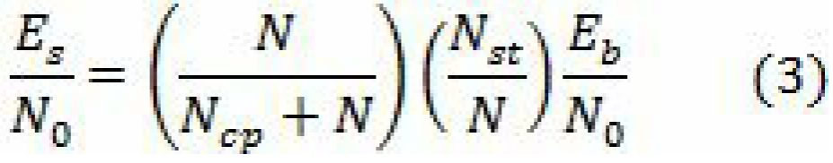
which, when converted to dB yields the following relationship.
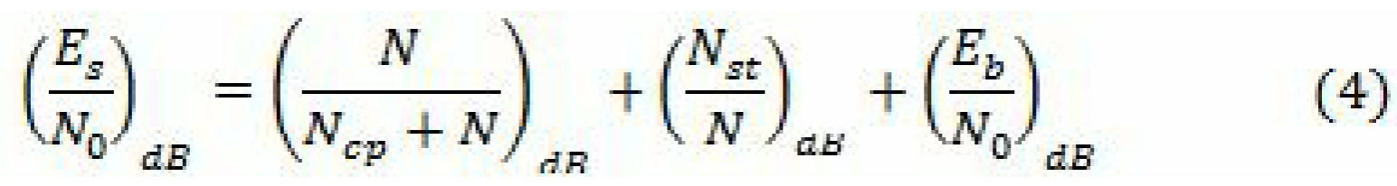
Since Ncp- cyclic prefixes are added to the OFDM symbol, the output signal from the parallel to
serial converter has to be boosted to compensate the wastage of energy associated with the addition
of cyclic prefix. To properly generate the required SNR in Matlab, the signal term at the output of the
parallel to serial converter has to be scaled as follows
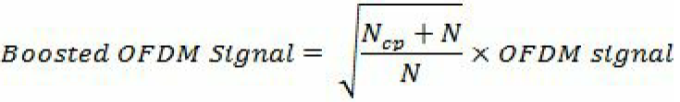
The received signal is represented as (for the given E b /N 0 )
Arrangement of subcarriers:
The IEEE 802.11 specification specifies how to arrange the given subcarriers. The 52 used
subcarriers (data + pilot) are assigned numbers from -26,-25, …,-2,-1 and 1,2,…,25,26. The
following figure illustrates the scheme of assigning these subcarriers to the IFFT inputs.

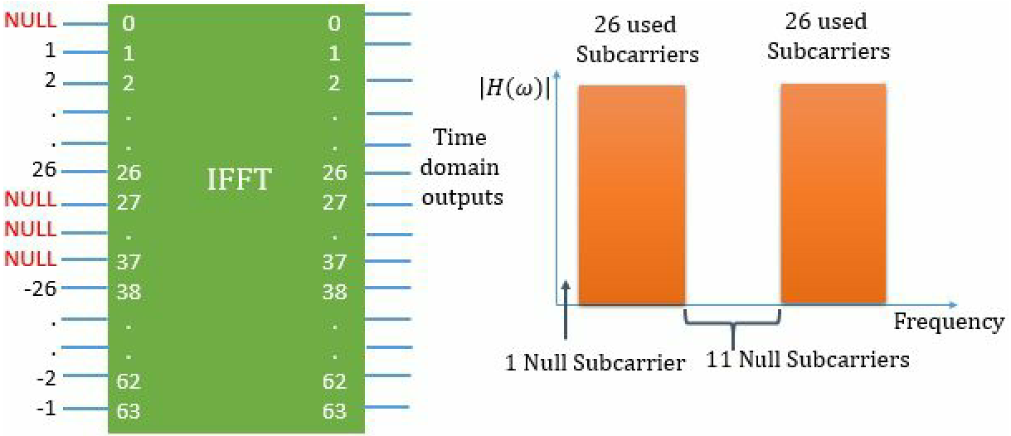

The schematic diagram of a simpliﬁed cyclic-preﬁxed OFDM (CP-OFDM) data transmission system is shown in Figure 1. The basic parameter to describe an OFDM system is to specify the number of subchan- nels (N) required to send the data. The number of subchannels is typically set to powers of 2, such as {64,256,512,1024, ···}. The size of inverse discrete Fourier transform (IDFT) and discrete Fourier trans- form (DFT) need to be set accordingly. The transmission begins by converting the source information stream into N parallel subchannels. For convenience, the information stream d is already represented as a symbol from the set {1, 2..., M}. The data symbol in each subchannel is modulated using the chosen modulation technique such as BPSK, QPSK or MQAM (refer chapter 5 for their models). Since this is a baseband discrete-time model, where the signals are represented at symbol sampling instants, the information symbol on each parallel stream is assumed to be modulating a single orthogonal carrier. At this juncture, the modulated symbols X on the parallel streams can be visualized as coming from different orthogonal subchannels in the frequency domain. The components of the orthogonal subchannels in the frequency domain are converted to time domain using IDFT operation. The following generic function implements the modulation mapper (constellation mapping) shown in the Figure 14.3. The function supports MPSK modulation for M ∈ {2,4,8, ···} and MQAM modulation that has square constellation: M ∈ {4,16,64,256,1024, ···}.
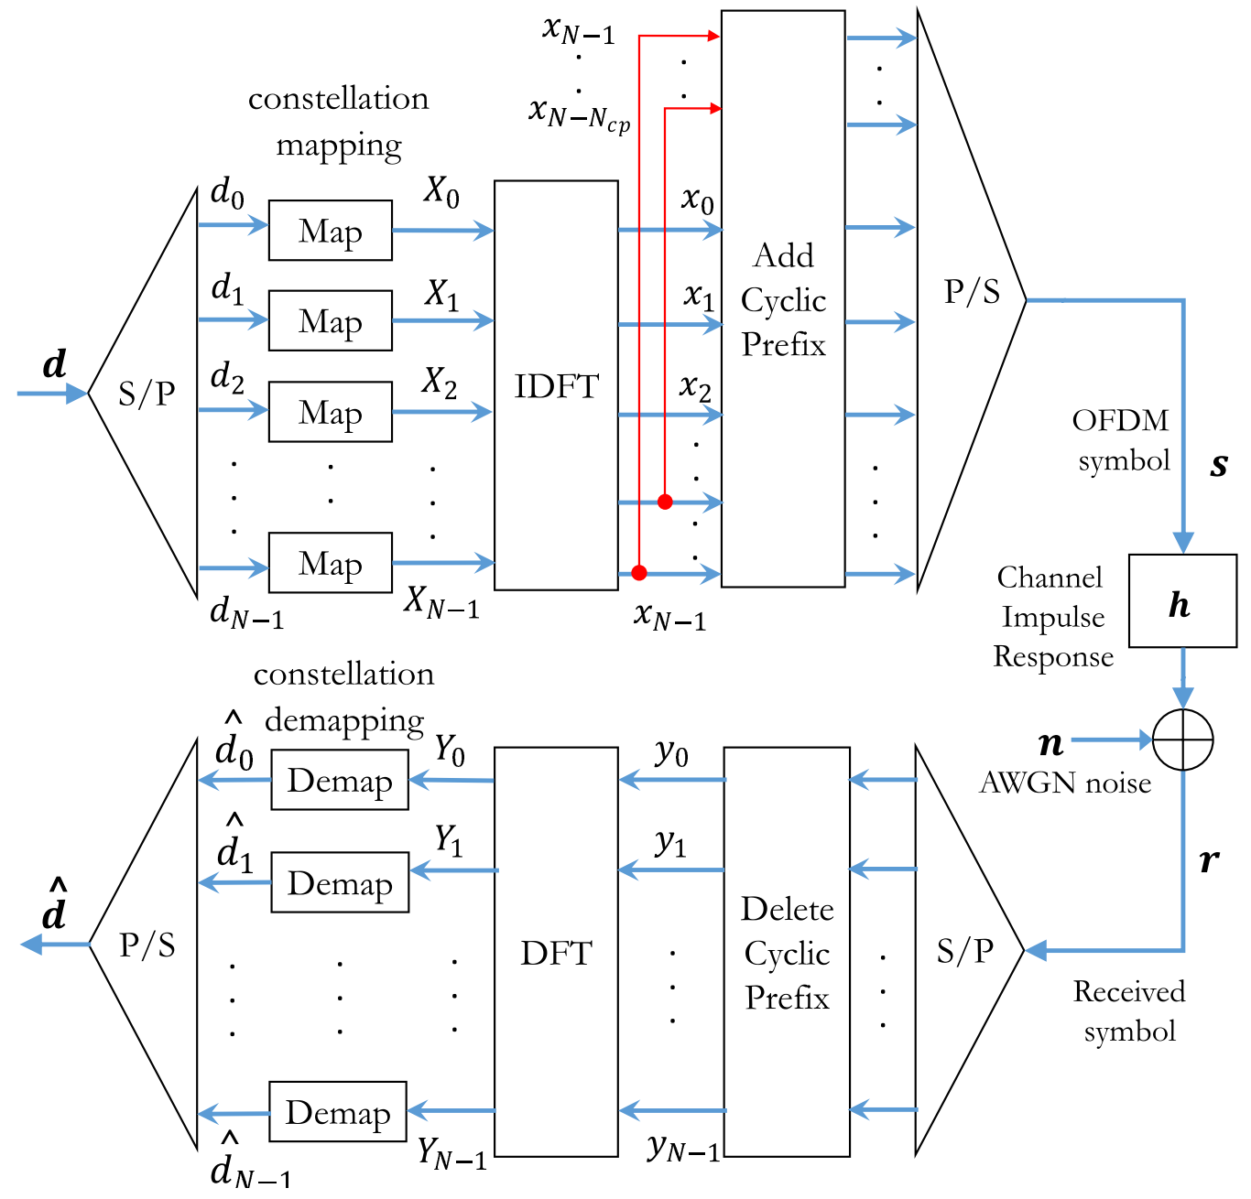
Fig. 1: Discrete-time simulation model for OFDM transmission and reception
OFDM signal is a composite signal that contains information from subchannels. Since the modulated symbols X are visualized to be in frequency domain, it is converted to time-domain using IDFT. In the receiver, the corresponding inverse operation is performed by the DFT block. The IDFT and DFT blocks in the schematic can also be interchanged and it has no impact to the transmission. In a time-dispersive channel, the orthogonality of the subcarriers cannot be maintained in a perfect state due to delay distortion. This problem is addressed by adding a cyclic extension (also called cyclic preﬁx) to the OFDM symbol [2]. A cyclic extension is added by copying the last Ncp symbols from the vector x and pasting it to its front as shown in Figure 2. Cyclic extension of OFDM symbol converts the linear convolution channel to a channel performing cyclic convolution and this ensures orthogonality of subcarriers in a time- dispersive channel. It also completely eliminates the subcarrier interference as long as the impulse response of the channel is shorter than the cyclic preﬁx. At the receiver, the added cyclic preﬁx is simply removed from the received OFDM symbol.
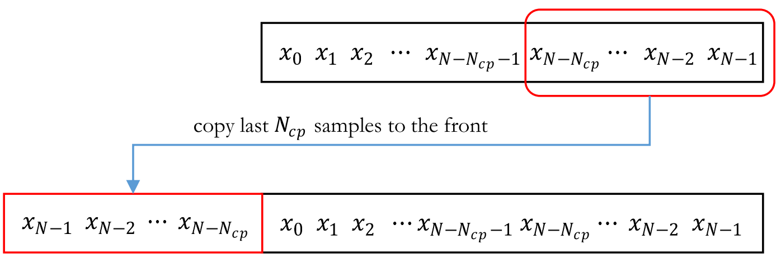
Fig. 2: Adding a cyclic preﬁx in CP-OFDM
On the receiver side, the demapper for demodulating MPSK and MQAM can be implemented by using a simple IQ detector that uses the minimum euclidean distance metric for demodulation.
Performance of MPSK-CP-OFDM and MQAM-CP-OFDM on AWGN channel
The code in student worksheet puts together all the functional blocks of an OFDM transmission system, that were described in previous section, to simulate the performance of a CP-OFDM system over an AWGN channel. The code supports two types of underlying modulations for OFDM - MPSK or MQAM. It generates random data symbols, modulates them using the chosen modulation type, converts the modulated symbols to frequency domain using IDFT operation and adds cyclic preﬁx to form an OFDM symbol. The resulting OFDM symbols are then added with AWGN noise vector that corresponds to the speciﬁed $E_{b} /N_{0}$ value. On the receiver side, cyclic preﬁx is removed from the received OFDM symbol, DFT is performed and then the symbols are sent through a demapper for getting an estimate of the source symbols. The demapper is implemented by using a simple IQ detector that uses the minimum euclidean distance metric for demodulation. Finally, the symbol error rates are computed and compared against the theoretical symbol error rate curves for the respective modulations over AWGN. The theoretical equations and the function to calculate symbol error rates for MPSK and MQAM modulations are given below.
AWGN channel
In this section, the relationship between SNR-per-bit (Eb /N0) and SNR-per-symbol (Es /N0) are deﬁned with respect to M-ary signaling schemes. Then the complex baseband model for an AWGN channel is discussed, followed by the theoretical error rates of various modulations over the additive white Gaussian noise (AWGN) channel.
Signal to noise ratio (SNR) deﬁnitions
Assuming a channel of bandwidth B, received signal power Pr and the power spectral density (PSD) of noise N0/2, the signal to noise ratio (SNR) is given by
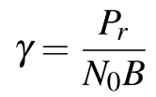
Let a signal’s energy-per-bit is denoted as Eb and the energy-per-symbol as Es , then γb = Eb /N0 and γs =Es /N0 are the SNR-per-bit and the SNR-per-symbol respectively. For uncoded M-ary signaling scheme with k = log2(M) bits per symbol, the signal energy per modulated symbol is given by
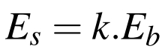
The SNR per symbol is given by
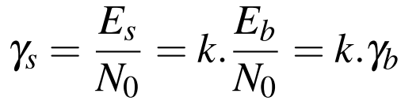
AWGN channel model
In order to simulate a speciﬁc SNR point in performance simulations, the modulated signal from the transmitter needs to be added with random noise of speciﬁc strength. The strength of the generated noise depends on the desired SNR level which usually is an input in such simulations. In practice, SNRs are speciﬁed in dB. Given a speciﬁc SNR point for simulation, let’s see how we can simulate an AWGN channel that adds correct level of white noise to the transmitted symbols.
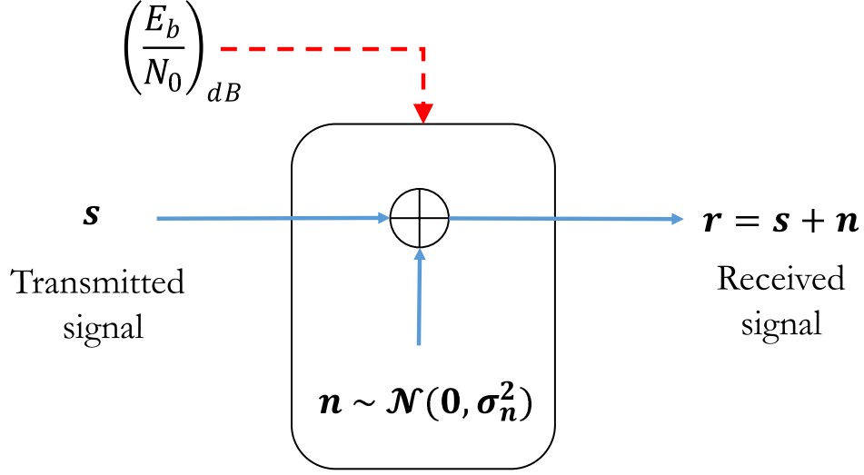
Fig. 3: AWGN noise model - computes and adds white Gaussian noise vector for a given SNR value
Consider the AWGN channel model given in Figure 3. Given a speciﬁc SNR point to simulate, we wish to generate a white Gaussian noise vector N (0,σ2) of appropriate strength and add it to the incoming signal. The method described can be applied for both waveform simulations and the complex baseband simulations. In following text, the term SNR (γ) refers to γb = Eb /N0 when the modulation is of binary type (example: BPSK). For multilevel modulations such as QPSK and MQAM, the term SNR refers to γs = Es /N0.
1. Assume, s is a vector that represents the transmitted signal. We wish to generate a vector r that represents the signal after passing through the AWGN channel. The amount of noise added by the AWGN channel is controlled by the given SNR - γ.
2. For waveform simulation model, let the given oversampling ratio is denoted as L. On the other hand, if you are using the complex baseband models, set L = 1.
3. Let N denotes the length of the vector s. The signal power for the vector s can be measured as,
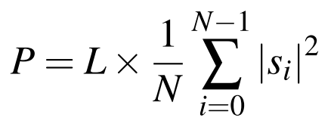
4. The required power spectral density of the noise vector n is computed as
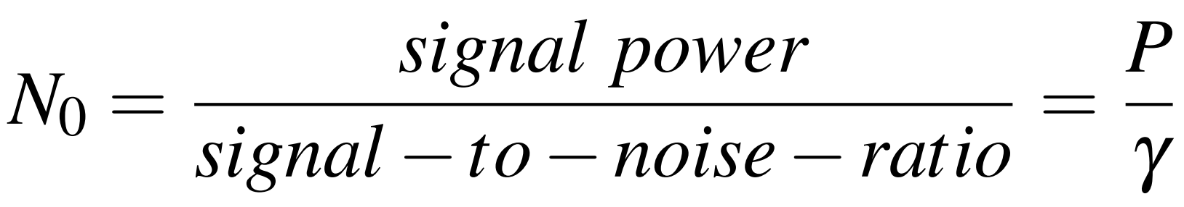
5. Assuming complex IQ plane for all the digital modulations, the required noise variance (noise power) for generating Gaussian random noise is given by
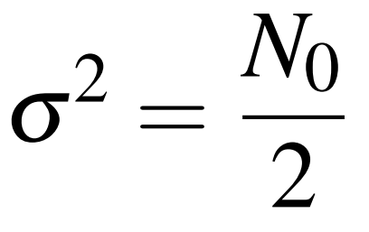
6. Finally, generate the noise vector n drawn from normal distribution with mean set to zero and the standard deviation computed from the above equation
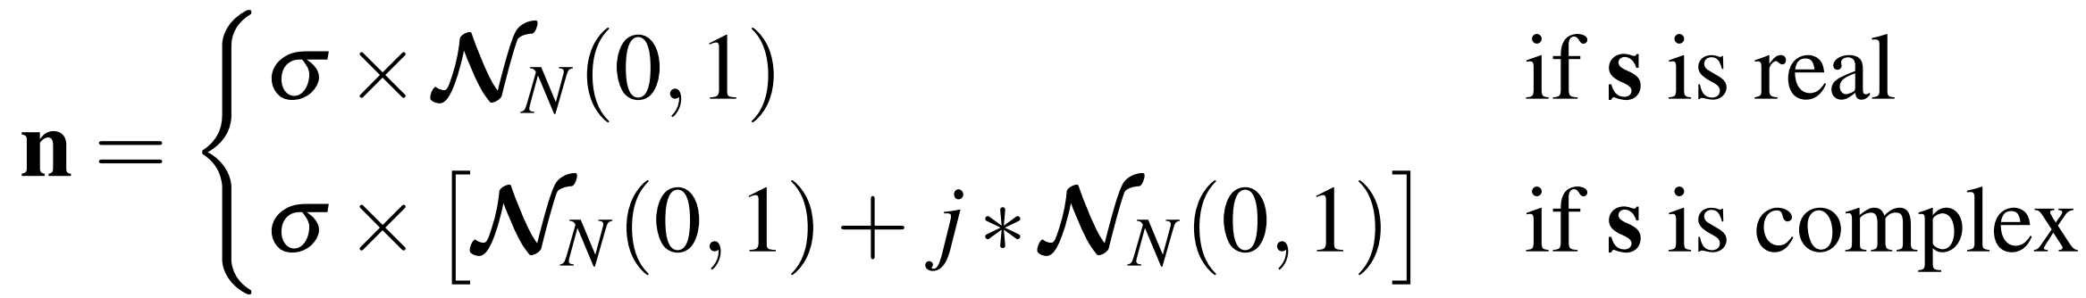
7. Finally add the generated noise vector to the signal s
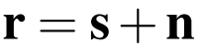
The following custom function written in Matlab, can be used for adding AWGN noise to an incoming signal. It can be used in waveform simulation as well as complex baseband simulation models.
Theoretical symbol error rates
Denoting the symbol error rate (SER) as Ps , SNR-per-bit as γb = Eb /N0 and SNR-per-symbol as γs = Es /N0, the symbol error rates for various modulation schemes over AWGN channel are listed below.
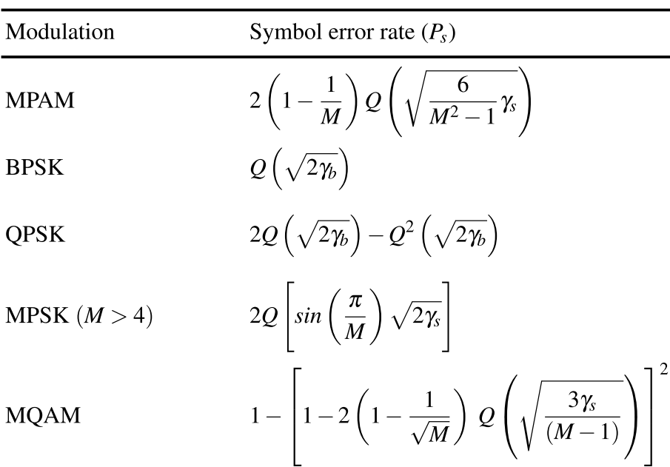
The theoretical symbol error rates are coded as a reusable function. In this implementation, erfc function is used instead of the Q function shown in the above table. The following equation describes the relationship between the erfc function and the Q function.
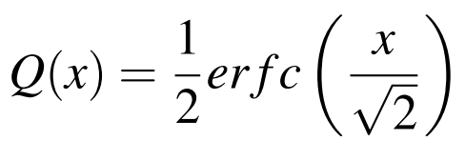

 | Sinhgad Technical Education Society’s  RMD Sinhgad School of Engineering, Warje, Pune.  Department of E&TC Engineering | Expt.No.  8
Title | OFDM – BER Vs Eb/N0
 | Student Worksheet

Problem Statement

Formula

Calculations

Conclusion
From the following simulated result, it can be ascertained that the OFDM- BPSK modulation has no advantage over a normal BPSK system in AWGN. OFDM proves to be effective in multipath environments.

Review Questions

 | Sinhgad Technical Education Society’s  RMD Sinhgad School of Engineering, Warje, Pune.  Department of E&TC Engineering | Expt.No.  8
Title | OFDM – BER Vs Eb/N0
Name
Roll No.

Program
- %Simulation of OFDM system in an AWGN environment
- %Follows IEEE 802.11 specification
- clear; clc;
- %--------Simulation parameters----------------
- nSym=10^4; %Number of OFDM Symbols to transmit
- EbN0dB = -20:2:8; % bit to noise ratio
- %---------------------------------------------
- %--------OFDM Parameters - Given in IEEE Spec--
- N=64; %FFT size or total number of subcarriers (used + unused) 64
- Nsd = 48; %Number of data subcarriers 48
- Nsp = 4 ; %Number of pilot subcarriers 4
- ofdmBW = 20 * 10^6 ; % OFDM bandwidth
- %----------------------------------------------
- %--------Derived Parameters--------------------
- deltaF = ofdmBW/N; %=20 MHz/64 = 0.3125 MHz
- Tfft = 1/deltaF; % IFFT/FFT period = 3.2us
- Tgi = Tfft/4;%Guard interval duration - duration of cyclic prefix
- Tsignal = Tgi+Tfft; %duration of BPSK-OFDM symbol
- Ncp = N*Tgi/Tfft; %Number of symbols allocated to cyclic prefix
- Nst = Nsd + Nsp; %Number of total used subcarriers
- nBitsPerSym=Nst; %For BPSK the number of Bits per Symbol is same as num of subcarriers
- %----------------------------------------------
- EsN0dB = EbN0dB + 10*log10(Nst/N) + 10*log10(N/(Ncp+N)); % converting to symbol to noise
- ratio
- errors= zeros(1,length(EsN0dB));
- theoreticalBER = zeros(1,length(EsN0dB));
- %Monte Carlo Simulation
- for i=1:length(EsN0dB),
- for j=1:nSym
- %-----------------Transmitter--------------------
- s=2*round(rand(1,Nst))-1; %Generating Random Data with BPSK modulation
- %IFFT block
- %Assigning subcarriers from 1 to 26 (mapped to 1-26 of IFFT input)
- %and -26 to -1 (mapped to 38 to 63 of IFFT input); Nulls from 27 to 37
- %and at 0 position
- X_Freq=[zeros(1,1) s(1:Nst/2) zeros(1,11) s(Nst/2+1:end)];
- % Pretending the data to be in frequency domain and converting to time domain
- x_Time=N/sqrt(Nst)*ifft(X_Freq);
- %Adding Cyclic Prefix
- ofdm_signal=[x_Time(N-Ncp+1:N) x_Time];
- %--------------Channel Modeling ----------------
- noise=1/sqrt(2)*(randn(1,length(ofdm_signal))+1i*randn(1,length(ofdm_signal)));
- r= sqrt((N+Ncp)/N)*ofdm_signal + 10^(-EsN0dB(i)/20)*noise;%-----------------Receiver----------------------
- %Removing cyclic prefix
- r_Parallel=r(Ncp+1:(N+Ncp));
- %FFT Block
- r_Time=sqrt(Nst)/N*(fft(r_Parallel));
- %Extracting the data carriers from the FFT output
- R_Freq=r_Time([(2:Nst/2+1) (Nst/2+13:Nst+12)]);
- %BPSK demodulation / Constellation Demapper.Force +ve value --> 1, -ve value --> -1
- R_Freq(R_Freq>0) = +1;
- R_Freq(R_Freq<0) = -1;
- s_cap=R_Freq;
- numErrors = sum(abs(s_cap-s)/2); %Count number of errors
- %Accumulate bit errors for all symbols transmitted
- errors(i)=errors(i)+numErrors;
- end
- theoreticalBER(i)=(1/2)*erfc(sqrt(10.^(EbN0dB(i)/10))); %Same as BER for BPSK over AWGN
- end
- simulatedBER = errors/(nSym*Nst);
- plot(EbN0dB,log10(simulatedBER),'r-o');
- hold on;
- plot(EbN0dB,log10(theoreticalBER),'k*');
- grid on;
- title('BER Vs EbNodB for OFDM with BPSK modulation over AWGN');
- xlabel('Eb/N0 (dB)');ylabel('BER');legend('simulated','theoretical');

Output

Program 14.1: modulation mapper.m: Implementing the modulation mapper for MPSK and MQAM
function [X,ref]=modulation_mapper(MOD_TYPE,M,d)
%Modulation mapper for OFDM transmitter
% MOD_TYPE - 'MPSK' or 'MQAM' modulation
% M - modulation order, For BPSK M=2, QPSK M=4, 256-QAM M=256 etc..,
% d - data symbols to be modulated drawn from the set {1,2,...,M}
%returns
% X - modulated symbols
% ref -ideal constellation points that could be used by IQ detector
if strcmpi(MOD_TYPE,'MPSK'),
[X,ref]=mpsk_modulator(M,d);%MPSK modulation
else
if strcmpi(MOD_TYPE,'MQAM'),
[X,ref]=mqam_modulator(M,d);%MQAM modulation
else
error('Invalid Modulation specified');
end
end;end

Program 14.2: add cyclic preﬁx.m: Function to add cyclic preﬁx of length Ncp symbols
function s = add_cyclic_prefix(x,Ncp)
%function to add cyclic prefix to the generated OFDM symbol x that
%is generated at the output of the IDFT block
% x - ofdm symbol without CP (output of IDFT block)
% Ncp-num. of samples at x's end that will copied to its beginning
% s - returns the cyclic prefixed OFDM symbol
s = [x(end-Ncp+1:end) x]; %Cyclic prefixed OFDM symbol
end

Program 14.3: remove cyclic preﬁx.m: Function to remove the cyclic preﬁx from the OFDM symbol
function y = remove_cyclic_prefix(r,Ncp,N)
%function to remove cyclic prefix from the received OFDM symbol r
% r - received ofdm symbol with CP
% Ncp - num. of samples at beginning of r that need to be removed
% N - number of samples in a single OFDM symbol
% y - returns the OFDM symbol without cyclic prefix
y=r(Ncp+1:N+Ncp);%cut from index Ncp+1 to N+Ncp
end

Program 14.4: ofdm on awgn.m: OFDM transmission and reception on AWGN channel
clearvars; clc;
%--------Simulation parameters----------------
nSym=10ˆ4; %Number of OFDM Symbols to transmit
EbN0dB = 0:2:20; % bit to noise ratio
MOD_TYPE='MPSK'; %modulation type - 'MPSK' or 'MQAM'
M=64; %choose modulation order for the chosen MOD_TYPE
N=64; %FFT size or total number of subcarriers (used + unused) 64
Ncp= 16; %number of symbols in the cyclic prefix

%--------Derived Parameters--------------------
k=log2(M); %number of bits per modulated symbol
EsN0dB=10*log10(k)+EbN0dB;%convert to symbol energy to noise ratio
errors= zeros(1,length(EsN0dB)); %to store symbol errors

for i=1:length(EsN0dB),%Monte Carlo Simulation
for j=1:nSym
%-----------------Transmitter--------------------
d=ceil(M.*rand(1,N));%uniform distributed random syms from 1:M
[X,ref]=modulation_mapper(MOD_TYPE,M,d);
x= ifft(X,N);% IDFT
s = add_cyclic_prefix(x,Ncp); %add CP

%-------------- Channel ----------------
r = add_awgn_noise(s,EsN0dB(i));%add AWGN noise r = s+n

%-----------------Receiver----------------------
y = remove_cyclic_prefix(r,Ncp,N);%remove CP
Y = fft(y,N);%DFT
[˜,dcap]= iqOptDetector(Y,ref);%demapper using IQ detector

%----------------Error counter------------------
numErrors=sum(d˜=dcap);%Count number of symbol errors
errors(i)=errors(i)+numErrors;%accumulate symbol errors
end
end
simulatedSER = errors/(nSym*N);
theoreticalSER=ser_awgn(EbN0dB,MOD_TYPE,M);

%Plot theoretical curves and simulated BER points
plot(EbN0dB,log10(simulatedSER),'ro');hold on;
plot(EbN0dB,log10(theoreticalSER),'r-');grid on;
title(['Performance of ',num2str(M),'-', MOD_TYPE,' OFDM over AWGN channel']);
xlabel('Eb/N0 (dB)');ylabel('Symbol Error Rate');
legend('simulated', 'theoretical');

